GRADE 7 ACCELERATED · UNIT 2 · LESSON 2  Square Values and Square Roots  Worksheet 7A.02.02 | Name_________________________  Date__________________________  Period________________________

1. Label the three parts of the radical expression.
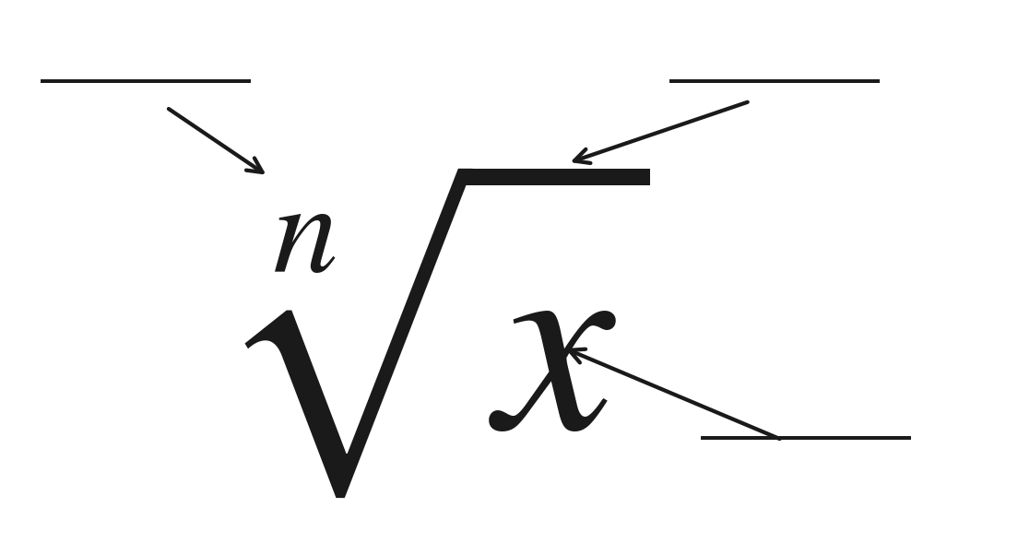
2. Fill in both boxes. They do not get the same answer, and the reason is the whole point of today.
The radical on its own | The equation
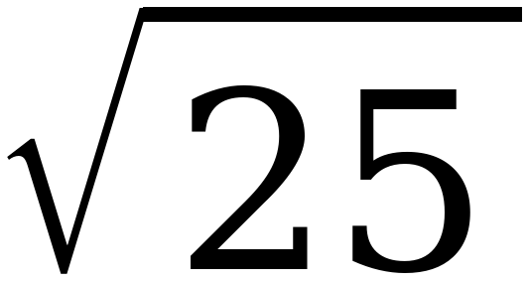 | x² = 25

For questions 3 through 6, find the value.
3. 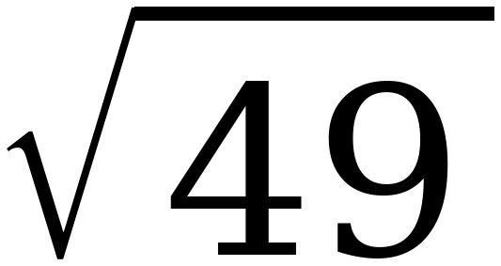

4. 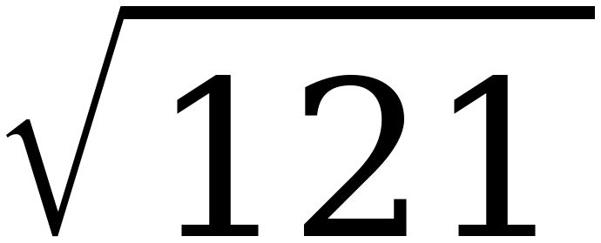

5. 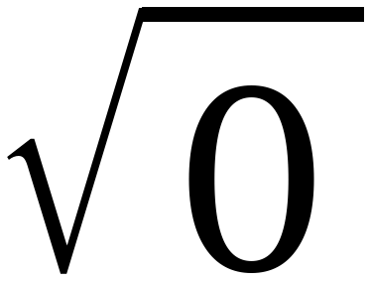

6. 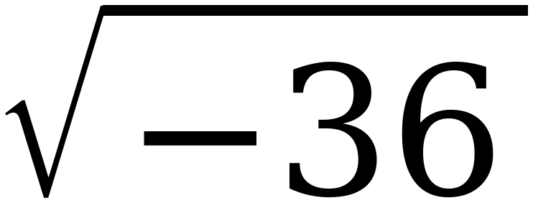

For questions 7 through 10, find every real solution of the equation.
7. x² = 64

8. 144 = m²

9. x² = 0

10. y² = −49

11. Select ALL of the values below that make x² = 81 true.
☐ | 9 | ☐ | 40.5
☐ | −9 | ☐ | 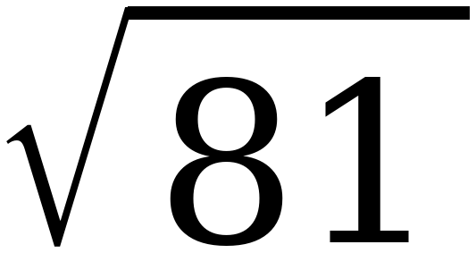
☐ | − | ☐ | 81²

12. Nadia writes the statement below on her paper.
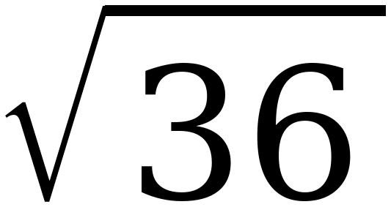 = ±6
Explain what is wrong with Nadia's statement, then write the two correct statements it should have been.

